Moodle Technical User Manual

Technical Moodle User Manual for the EU4ALL components



Deliverable:
Work Package:
Partners: | IPL
Workpackage
Task | T6.4.1 Set-up and implementation of the EU4ALL framework in further institutions
Date of delivery | Contractual |  | Actual
Code name | IPL-EU4ALL_moodle_technical_user_manual.odt |  | Version 1.0.245
Type of deliverable | Report
Security
(distribution level)
Contributors | Manuela Francisco (IPL), Catarina Maximiano (IPL), Vítor Rodrigues (IPL)
Authors (Partner) | Cláudio Esperança (IPL)
Contact Person
WP/Task responsible | IPL
EC Project Officer
Abstract | This document provides an overview of the user's perspective in using the Moodle prototype developed by IPL.
Keywords List | EU4ALL, Moodle, IPL, User model, Metadata repository, Content personalization, Technical user manual
EU4ALL Project Coordinator: Lydia Montandon (Atos Origin)
Tel: +34 91214 8616; fax: +34 91754 3252; mobile: +34 680 647 915
email: lydia.montandon@atosorigin.com

Table of Contents
1 Introduction 6
2 Moodle VLE actions 7
2.1 Administrator actions 7
2.1.1 View EU4ALL accessibility preferences capabilities 7
2.1.2 View EU4ALL content adaptations capabilities 9
2.1.3 Edit EU4ALL plugin settings 10
2.2 Teacher and/or tutor actions 12
2.2.1 Set the EU4ALL course format 12
2.2.2 View the resource alternatives 13
2.2.3 Manage the resource alternatives 13
2.3 Student actions 16
2.3.1 Edit EU4ALL accessibility preferences 16
2.3.2 View EU4ALL accessibility preferences 17
2.3.3 Presentation of digital content 18

List of Figures
Figure 1: EU4ALL Moodle role capabilities for the 'authenticated user' 8
Figure 2: EU4ALL format capabilities 10
Figure 3: EU4ALL Moodle plugin settings 11
Figure 4: Course format settings 12
Figure 5: Course topic view by an editing teacher 13
Figure 6: Insert "Adaptable" resource 14
Figure 7: Describing an "adaptable" 15
Figure 8: Edit EU4ALL accessibility preferences 16
Figure 9: View EU4ALL accessibility preferences 18
Figure 10: Content adaptation 19

List of abbreviations
EU4ALL European Unified Approach for Accessible Lifelong Learning
LMS Learning Management System
IPL Instituto Politécnico de Leiria (Polytechnic Institute of Leiria)
UM User Model
CP Content Personalization
MR Metadata Repository
PHP PHP Hypertext Preprocessor
LAMP – Linux Apache MySQL PHP
VLE – Virtual Learning Environment

Introduction
The aim of this document is to describe the IPL Moodle implementation of the EU4ALL framework from the user perspective and it will focus on the administrator, teacher (or tutor) and student (or learner) views of the system and how to use them.

Moodle VLE actions
This chapter will demonstrate some of the actions available to the Moodle VLE users when using the EU4ALL Moodle components:
- View and edit EU4ALL user accessibility preferences
- Insert and manage adapted resources (or adaptations)
- Presentation of digital content (or resources) that are suited to a specific EU4ALL user profile
- View EU4ALL specific capabilities for an user or role
- Edit EU4ALL Moodle plugin settings
There are a number of additional actions that could be considered, but are currently ruled out of the scope of this document. These include:
- Adding new user accounts to the Moodle system
- Adding a new course to the system
- Adding resources to a course
- Authentication on the Moodle VLE
- Installation of the EU4ALL Moodle components

Administrator actions

View EU4ALL accessibility preferences capabilities
The Moodle system administrators can allow or prohibit the editing or the viewing of the EU4ALL accessibility preferences by the users with a specific role on the VLE.
- As a Moodle system administrator go to the option on the “Settings” block (1).
Site administration->Users->Permissions->Define roles
- Click on the Role name and filter the capabilities using the keyword (2)
eu4all
- The EU4ALL Moodle capabilities should appear (3)
By default all the authenticated users can view and update their own profile (“View own EU4ALL profile” and “Edit own EU4ALL profile” capabilities) as can be seen on the figure 1.
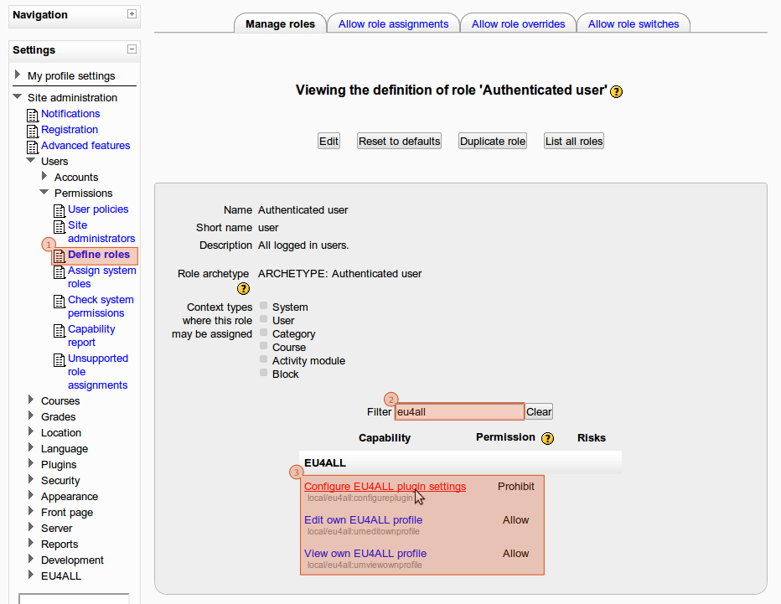Figure 1: EU4ALL Moodle role capabilities for the 'authenticated user'
The capability “Configure EU4ALL plugin settings” defines who can configure the EU4ALL plugin settings and it is only allowed to system administrators by default.

View EU4ALL content adaptations capabilities
The Moodle system administrators can control which user roles are allowed to see the resources alternatives. By default only teachers (editing teachers) or “above” can see and manage the content alternatives from a specific resource.
To see which roles have this capability an administrator can search for on page “Capability report” on the menu option to get a report from the “format/adaptable:viewadaptables” capability as presented on the figure 2.
format/adaptable
Site administration->Users->Permissions->Capability report
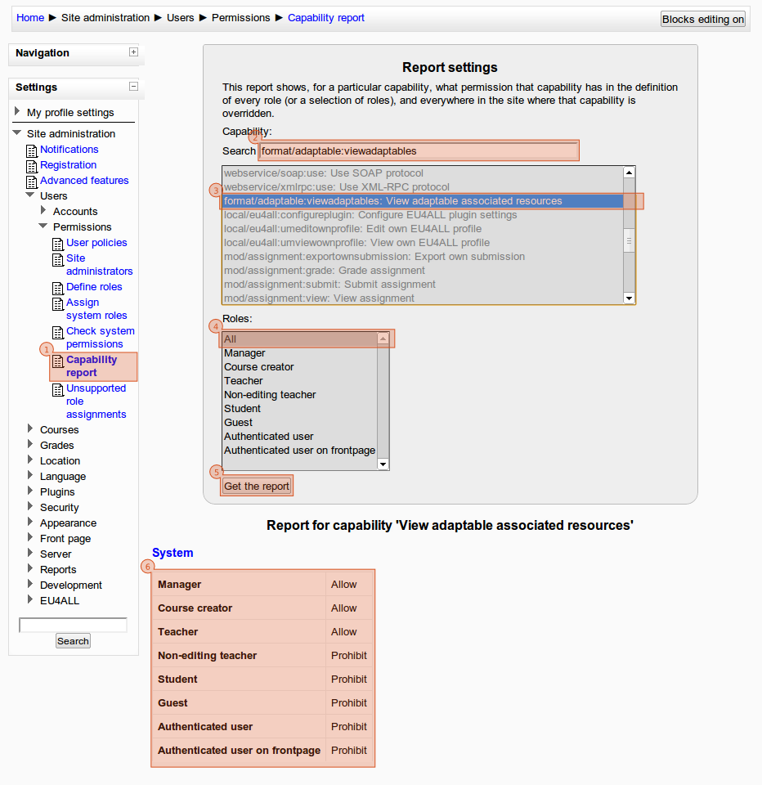Figure 2: EU4ALL format capabilities

Edit EU4ALL plugin settings
The Moodle VLE administrators or the users with a role with the capability“Configure EU4ALL plugin settings” (as seen on the section 2.1.1) are allowed to configure the EU4ALL Moodle plugin (figure 3).
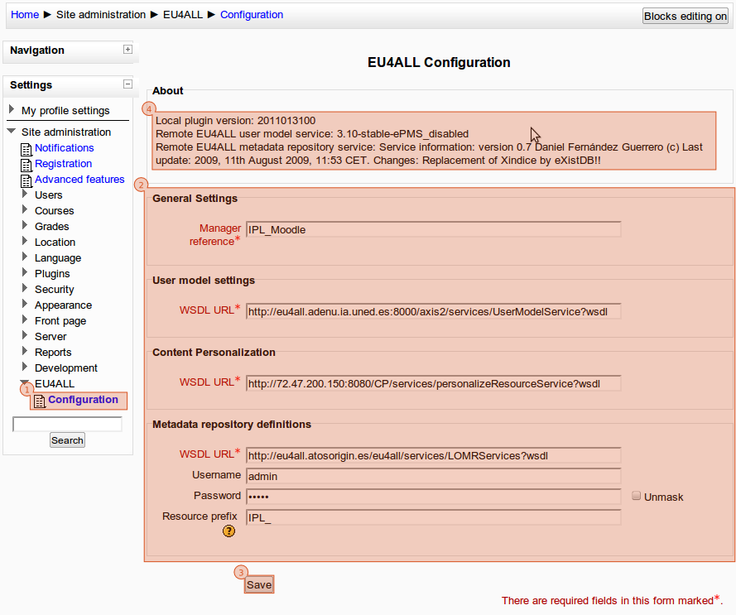Figure 3: EU4ALL Moodle plugin settings
- As a Moodle system administrator go to “Settings” block and click on the option (1).
Site administration->EU4ALL->Configuration
- Update the plugin settings based on your definitions (2). The update of the Manager reference and resource prefix is highly recommended.
- Save your settings (3)
- If this page is refreshed again (to assume the saved data), the system will present some information about the remote services (4).

Teacher and/or tutor actions

Set the EU4ALL course format
To use the EU4ALL framework on a course the “EU4ALL topics format” should be enabled for that course.
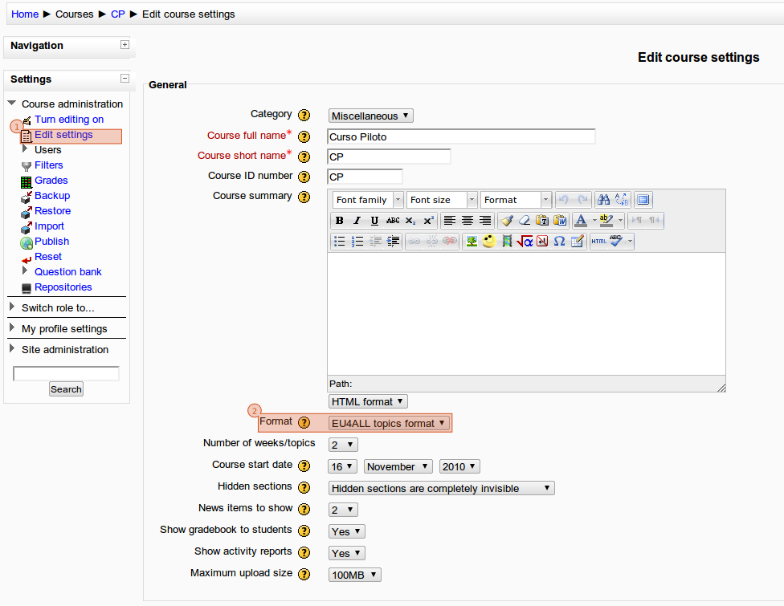Figure 4: Course format settings
- As a Moodle editing teacher go to “Settings” block and click on the option (1).
Course administration->Edit settings
- Select the “EU4ALL topics format” on the “Format” combo box (2) and save the changes.

View the resource alternatives
As discussed on the section 2.1.2, an user with the “format/adaptable:viewadaptables” capability (editing teacher) can see the relations between the resources and their alternatives or enhancements when visiting the course with the “EU4ALL topics format”.

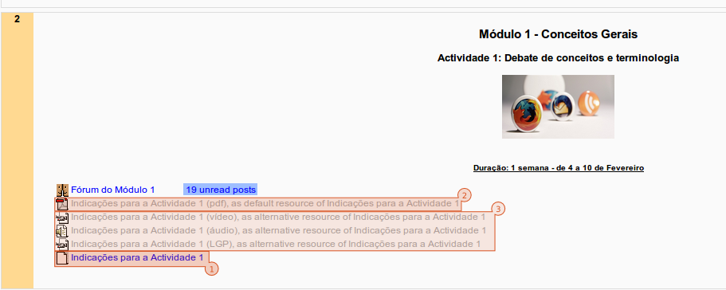Figure 5: Course topic view by an editing teacher
The figure 5 shows a topic of a course on the Moodle VLE from the editing teacher perspective. The user can see a special resource called adaptable (1), the resource that will be presented to the users when viewing the topic. When a student clicks on this resource, the Moodle will make a request to the EU4ALL framework to retrieve the resource identifier of a resource to be presented to the user: if there is an alternative to be presented, the Moodle will show that resource (e.g., one of three resources of the box number 3 on the figure 5); if no alternative is available (or on error), the Moodle will show the default resource (e.g., the resource hinted by the box number 2 on the figure 5).

Manage the resource alternatives
Like on the View the resource alternatives, to manage resource alternatives it is necessary the “format/adaptable:viewadaptables” capability for the authenticated user. By default all the editing teachers have this capability allowed on their role, but the administrator can override this behaviour like we have seen before.
The work flow to insert a resource and their alternatives is relatively simple:
- Insert the default resource (or content) to be presented to the users as default, for example, when an user doesn't have any disability.
- Insert the resource alternative(s) to be presented as the replacement for the default resource.
- Insert an resource from the type “Adaptable” to establish the relations between resources and publish this information to the EU4ALL central repository. This resource doesn't provide content per se but is a necessary abstraction to access the alternatives of a resource.
The steps 1 and 2 are pretty straight forward for any teacher familiar with the Moodle VLE and are beyond the scope of this document.
To insert an “Adaptable” the following steps are required:
- On a course, as an editing teacher, turn the edit mode on.
- On the topic where the link to the resource should appear, expand the combo box “Add a resource...” and select “Adaptable”.
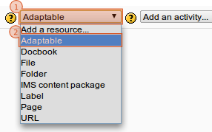Figure 6: Insert "Adaptable" resource
- Give a name for the resource (this is the name of the link that will appear to all users when viewing the parent topic - 1) and fill the meta data information that define the default resource (2) and their alternative(s) (3). All “adaptables” should have at least a default resource set and can have zero or many alternative resources associated (use the buttons “Add a new resource alternative” - 5 – or “Resource alternative #” - 4 – to, respectively, add or remove a resource alternative from the adaptable). All the resources associated with an “adaptable” cannot be associated with other “adaptables”.
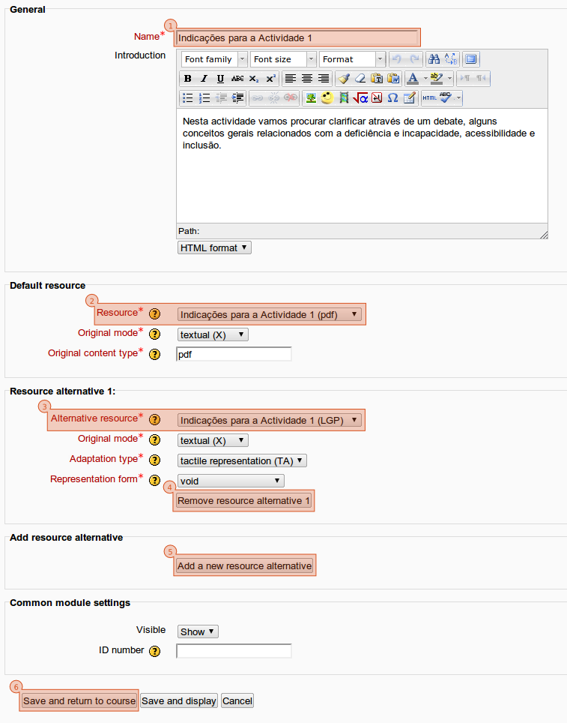Figure 7: Describing an "adaptable"
- Save the “adaptable” resource (6). This will send the meta data about the resources associated with this resource to the EU4ALL central repository.

Student actions

Edit EU4ALL accessibility preferences
The student should update their accessibility preferences as soon as possible, so the system can provide the correct adaptations based on the user preferences and needs. To do this, the following steps are required:

- As a Moodle student go to “Navigation” block and click on the option (1).
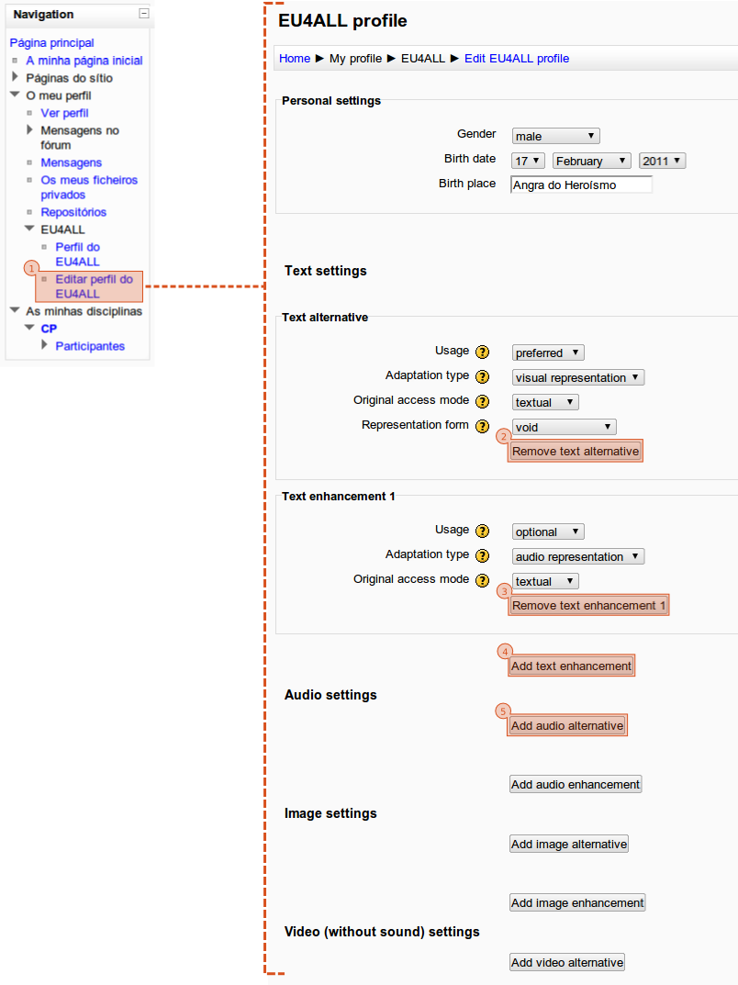Figure 8: Edit EU4ALL accessibility preferences
My profile->EU4ALL->Edit EU4ALL profile
- On the “Edit EU4ALL profile” page, update the personal settings and define the accessibility preferences for each content type. A content type can only have zero or one alternative content but there's no restriction on number of enhancements. The user should use the buttons on the form to add or remove alternatives and enhancements (3, 4, 5).
- When ready, the user should press “Save changes” to submit the profile information do the EU4ALL repository.

View EU4ALL accessibility preferences
The user can see their accessibility preferences at any time using the option on the “Navigation” block.
My profile->EU4ALL->EU4ALL profile
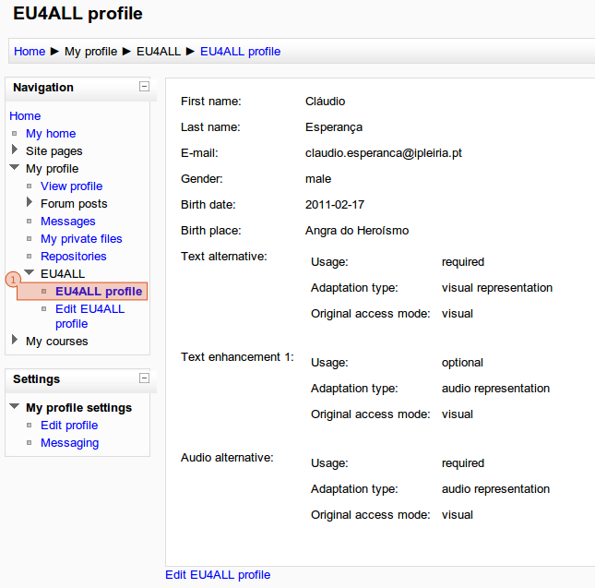Figure 9: View EU4ALL accessibility preferences
The plugin does not save the EU4ALL user accessibility preferences locally and the data shown on this page are the same available on the central repository.

Presentation of digital content
Based on the EU4ALL user accessibility preferences and the resources available, the framework can show a resource more suitable for the user than the default one. This process is totally transparent for the user.
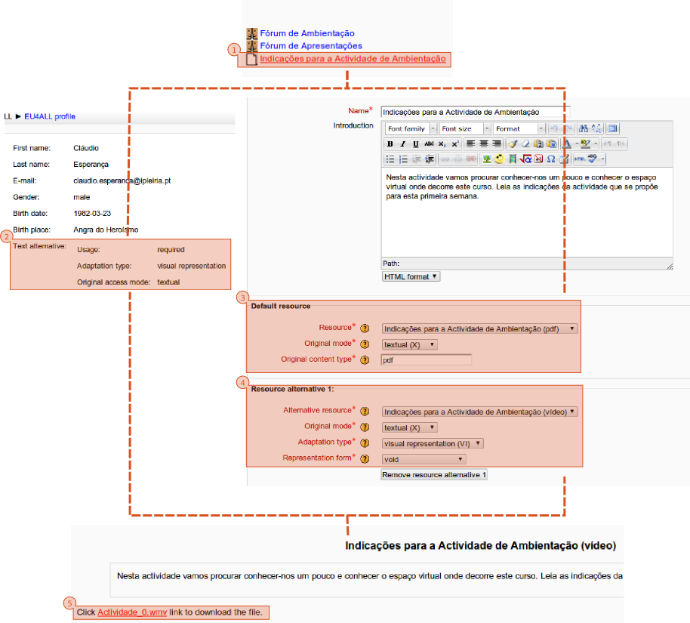Figure 10: Content adaptation
- The user clicks on a resource on the Moodle VLE (1).
- The resource “adaptable” make a request to the EU4ALL central repository asking for the best resource for the user based on their accessibility preferences (2). If a better resource is found, the EU4ALL framework will return the identifier to that specific resource (4), otherwise the default resource identifier will be used (3).
- The adaptable redirect the request for resource to be shown (5).

